A Long Way Gone Web Search

Using the Internet, find answers to the following questions, all of which pertain to the non-fiction text we will be reading next, A Long Way Gone. Answer using complete sentences!
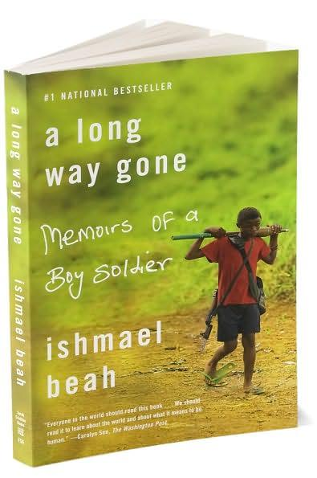
The Book

- Who is the author of A Long Way Gone?
- Where does he currently live?
- This book is considered a memoir. Look up this term. Explain what this term means.
- When was this book published?
- Is this book a work of fiction (not-real) or non-fiction (real)?
- What awards /recognition has A Long Way Gone received?
- Write a brief summary of what this book is about. If you use a summary from a web site, be sure to give credit to the website by writing down where you got your information from.

Conflict Diamonds

- What are conflict diamonds?
- What is another name for conflict diamonds?
- What is the reason behind this 2nd name for conflict diamonds?
- Where are the majority of conflict diamonds found?
- What are the conflict diamonds used for?

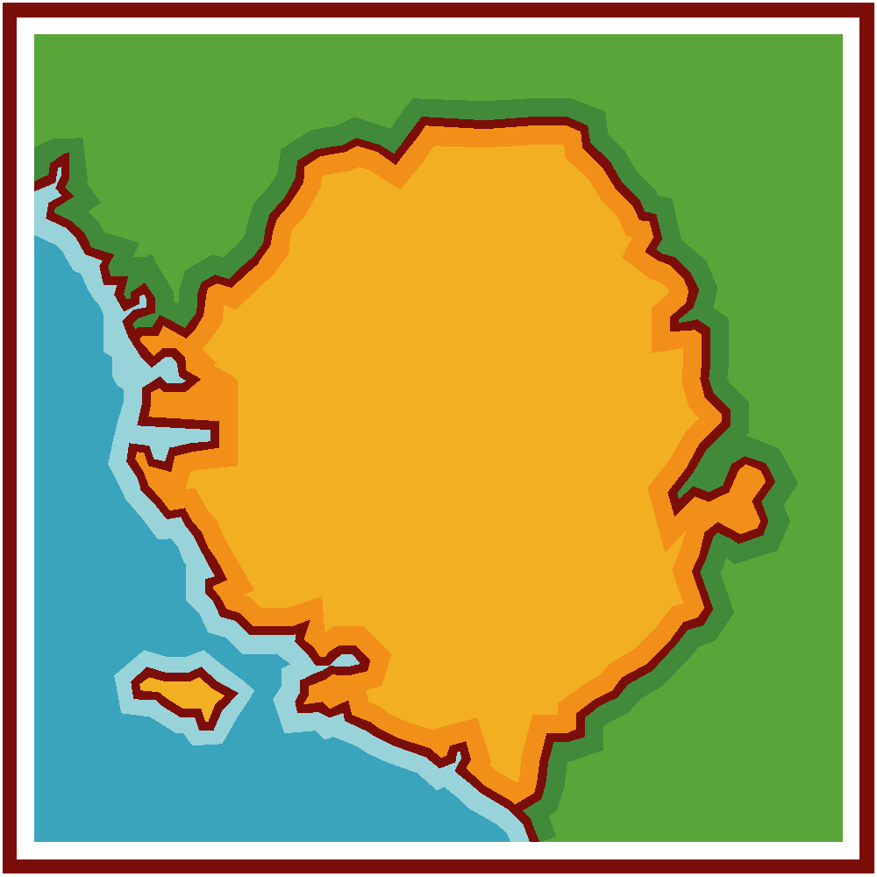
Civil War

- Where is Sierra Leone?
- What countries/bodies of water are on its borders?
- How long did the civil war in Sierra Leone last? (dates from start-finish)
- What was the RUF – what did it stand for?
- Explain who/what the RUF was.
- How did the RUF mainly terrorize people?

